White-faced Darter Activity

Worksheet 1

1. Within White-faced Darter larvae you find a range of variation in ______________________. These differences are caused by ___________ variations between individuals.

2. ________ are passed on when an individual reproduces. As a result, offspring ____________ variations from their parents.

3. Some White-faced Darter _________ have genes that produce __________________ that provide them with a better chance of surviving in ponds with ____________ because ____________________________________________. More individuals with this variation will survive until adulthood and __________________.

4. Some ___________have genes that produce ___________________ that provide them with a low chance of surviving.

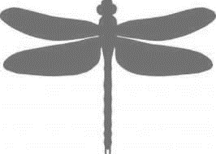
5. What is the natural selection pressure on the larvae? _______________________________

6. What is the evolutionary response? ______________________________________________

